First Pres Evanston Mission Council invites you to Come and See…

Come and See what God is doing through our amazing mission partners!
We are richly blessed by our relationships with our mission partner friends. They encourage & challenge us with their dedication and witness. Come with us to see a few partners in 2020.

June 4 – 20 Come and See our mission partners in Bethlehem, Palestine.
Choose one, two or three of the following:

- June 5-9 with two mission partners in Bethlehem: our sister church (Bethlehem Christmas Lutheran Church & Bethlehem Bible College as they jointly sponsor the 6th Christ at the Checkpoint conference

The theme will be Hope and Resilience in a Broken World.
https://christatthecheckpoint.bethbc.edu/
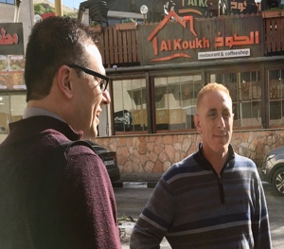
- June 9-14 with our IFES mission partner, CSPU (Christian Students of Palestinian Universities). This will include working with Nader, CSPU General Secretary and his volunteer team and with Rev. Munther Isaac, Chairman of the CSPU Board visiting campuses, meeting with student and faculty leaders, involved in summer training activities.
- June 14-19 with our mission partner, Rev. Mitri Raheb, Bright Stars of Bethlehem and Dar Al Kalima University as they celebrate their 25th anniversary and host the Bethlehem 2020 Connects conference. Bethlehem has been declared the cultural capital of the Arab world in 2020.

The theme is “Arts of Resistance and Voices of Hope”.

August 23-30 Come and See the Middle East & North Africa Regional Student Conference to be held in Alexandria, Egypt.

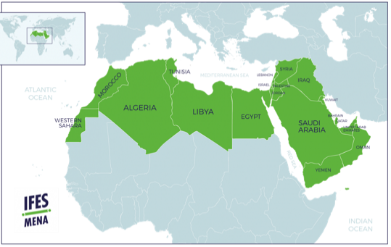
- Once every three years university students from across the Middle East and North Africa (MENA). Our church has partnered with The International Fellowship of Evangelical Students (IFES) in the MENA region for the past 15 years. And this is a great opportunity to see how God has opened doors in nearly every country in this region.

Through Bible preaching, workshops, worship, Bible study, and informal discussions over meals, students are challenged to live fully for the Lord -- our prayer is to see transformed students shaping universities across the Middle East and North Africa.

This gathering meets at Beit El Salaam Retreat Center on the Mediterranean coast.
October 5-12. Come and See our newest mission partner, Tavriski Christian Institute (TCI), Kherson, Ukraine. Valentin Sinyi (President) and Sergey Jishkariani (VP External Affairs) met with our Mission Council in November 2019 to introduce their training of pastors..

- TCI is the first Evangelical School to received a state license. They are formally recognized as an educational institution. This has allowed them to reach out to different people groups in the area and surrounding countries. They are able to travel to these countries with visas as tradesman, carpet-makers. Then In the evenings they have classes around a meal.

This mission trip TCI is leading a group of partners to Kyrgyzstan in Central Asia where local pastors are planting churches. We will visit first churches in Ukraine and then meet with church pastors and leaders in their homes in Kyrgyzstan.

Date to Be Determined. Come and See the work of our own First Pres members, Jim and Amy McAuley, and their work in Whiteriver, Arizona with the Hopi Native Americans.

- This trip will be organized as a study group. Jim and Amy share how critical it is for us to be like Christ who became human so that he might best understand, identify with and connect deeply in every way with the needs and brokenness we all have.

Jim and Amy will construct a curriculum of reading, discussion and experience to understand more deeply the Native American experience, especially the depth of the destruction of so much of their cultures and ways, the genocide of so many of their peoples, and the depth of their despair, homelessness, unemployment and hopelessness. Eight of the ten poorest counties in the US are Native American counties.

In John 1 Jesus calls his first disciples by saying Come and See. When the first two disciples see and meet Jesus, they both invite their brothers to Come and See Jesus. After the four of them meet Jesus, Jesus invites each of them to Follow Him.

This is our goal for each of these trips –
to Come and See Jesus and to Follow Him as His disciples.
Guidelines for Applying and Preparing for a First Pres Mission Trip in 2020

- Contact Caryl Weinberg, Director of Missions, or any member of the Mission Council
to begin discussions, to share interest and to consider the following steps.
(See any of the following: Cam Traut, Susan Wilkins, Sonia Bodi, Ron Ehresman, David Ivaska,, Younan Shiba, Barb Smith, Peter Steffen, Richard Taiwo, Dick Warnecke, Sharyn Wilson Woods)

- Fill out application for participating in a First Pres Evanston short term mission trip.
(see either Caryl Weinberg or Kelly Levander at the Church Office.

- Contact Caryl Weinberg to arrange an appointment to meet with her or one of the Mission Council to discuss any questions you may have or we may have.

- Gather further details about the mission trip you are interested. For example, visas, costs, schedules, booking flights, insurance, shots, etc. These will become available at the church office as soon as details are finalized with our mission partners.

- Work through a daily devotional on Paul’s letter to the Philippians. This is a 20-day brief Bible study guide that helps prepare you with those attitudes, convictions, joys and challenges that characterize a servant and a mission partner. These are best exemplified by Jesus and imitated by the Apostle Paul.

- Find 3 prayer partners who will pray for you regularly. Find 5 donor partners who will assist you in raising any necessary funds. There will be some funds available through the Mission Council, but only after your efforts were undertaken.

- Read any recommended materials that will help introduce you to the country and mission partner you are visiting.

- Meet with the mission trip Leader at least 2 times before the trip to answer questions and prepare for the trip.
Meet with the mission trip leader both at the beginning and end of the trip to best understand this time together with our mission partner.
Meet with the mission trip leader and others within the first month after returning to evaluate your experience and share any steps you have in following Jesus afterwards.

- To commit to becoming an advocate for the mission partner and/or the work of missions in or through the church.

